Kelly Knutson
1310 Bear Creek Rd.
Colville, WA 99114
509-864-8384; FAX 509-864-8381; E-mail Kelly_Knutson@fws.gov

RH: Deer/pig population sampling on Guam • Knutson and Vogt

PHILIPPINE DEER AND FERAL PIG POPULATION SAMPLING ON NORTHERN GUAM
KELLY KNUTSON, Andersen Air Force Base, Unit 14007, 36CES/CEVN
APO AP 96543
SCOTT VOGT, U.S. Fish and Wildlife Service, PO Box 8134, MOU-3, Dededo,

GU 96912

Abstract: Prior studies have indicated that the high populations of both exotic deer and pigs on Guam are having severe impacts on endangered species habitat. Up until now, no reliable population estimates have been made. From data collected in 2000-2001, using drive and spotlight counts, we provide statistically derived estimates of deer and pig populations. Our estimates indicate that areas of Andersen Air Force Base (AAFB) have exotic deer densities of 1.83 deer per hectare (95% confidence interval = 1.44-2.21) and feral pig densities of 0.38 pigs per hectare (95% confidence interval = 0.20-0.55). When compared with known ungulate densities from other regions, it appears that Guam has some of the highest ungulate densities in the world; substantial reduction may be required to recover the endangered species habitat.
JOURNAL OF WILDLIFE MANAGEMENT 00(0):000-000
Key Words: Philippine deer, Cervus mariannus, feral pigs, Sus scrofa, Guam, Pacific islands, population sampling, exotic ungulates, endangered species habitat.

INTRODUCTION
The most infamous alien species on the island of Guam is the Brown Treesnake (Boiga irregularis). It has been held responsible for the extinction/extirpation of numerous native bird species on the island (Savidge 1987). Unfortunately, this ecological disaster does not end with the Brown Treesnake. Guam is host to numerous non-native species that have disrupted the ecological balance of the island, to include the introduction of feral pigs (Sus scrofa), and Philippine deer (Cervus mariannus).
Mariano Tobias, the Spanish governor of the Marianas from 1771 to1774 is credited with bringing Philippine deer, C. mariannus, to Guam (Wiles et al. 1999). Spanish colonizers introduced domestic pigs, S. scrofa, to the Marianas between 1672 and 1685 (Intoh 1986).
Signs of over-browsing, rooting activity, destructive wallowing, feeding and trampling of vegetation are common in most forested areas on Guam and can be quite severe at some locations (Conry 1988, Wiles et. al. 1999). Eighty two percent of vegetation sampling plots (41 of 50) at Northwest field on Andersen Air Force Base (AAFB) showed signs of ungulate damage (Morton 1998). Although these papers have anecdotally described the overpopulation of ungulate species and the resulting impact on the native habitats on northern Guam, no reliable population sampling of the ungulates has been conducted
The Guam Division of Aquatic and Wildlife (GDAWR) has collected population index information using nighttime spotlight counts since 1963 (Wiles et. al. 1999), but this information has resulted only in trend information, with no statistically valid population estimate. Extrapolation of spotlight count information from 1997 suggested a minimum density of 48.3 deer/km² for the Munitions Storage Area (MSA-1) on AAFB (Wiles et. al. 1999). However, due to the dense vegetation it was felt that the minimum density had a more realistic estimate of 60-80 deer/km² for MSA (Wiles et al. 1999). The authors surmised that this constituted one of the highest densities of C. mariannus anywhere in its geographic range (Wiles et al. 1999). Perry and Morton (1999) noted that ungulate surveys in Northwest field of AAFB suggested a population decrease in the late 1970’s (Wheeler 1979), an increase during the 1980’s (Conry 1986, Aguon 1990), and a decrease in the 1990’s (G.J. Wiles pers. com.). However, these surveys are admittedly unreliable (Conry 1986) and not completely comparable (Perry and Morton 1999).
According to Wiles et al (1999), the objectives of current deer management programs (as a game species for sustained harvest) in the Marianas are not compatible with the conservation of native ecosystems and recovery of endangered species. Browsing damage to native forests is extensive, causing significant changes in forest structure and species composition. Due to hunting restrictions and anti-poaching programs (although poaching does still occur), the deer densities are considered to be higher on Guam’s military bases (Air Force and Navy) than elsewhere (Wiles et. al. 1999).
Perry and Morton (1999) offered three hypotheses to explain slower limestone forest regeneration on Guam than on other islands in the Marianas:. past use patterns by humans, cascading ecological effects due to extermination of pollinators and seed dispersers by the brown treesnake, and ungulate damage.
Even with this information available, no data has been gathered on absolute population numbers, the projected population levels (or harvest goals) required to alleviate browsing and rooting damage to native vegetation and endangered species habitat. Accurate and precise indices of deer and feral pig populations are necessary to those managing for sustainable yield, reduction, or eradication. However, pigs and deer are difficult to count because of their wide-ranging movements, preference for dense vegetation, generally low densities, highly aggregated distribution patterns, and rapidly changing densities resulting from high productivity (Barrett 1982, Anderson and Stone 1994).
The habitat on AAFB contains some of Guam’s last known populations of the endangered Mariana fruit bat (Pteropus mariannus), Mariana crow (Corvus kubaryi), Hayun lagu trees (Serianthes nelsonii) and nesting habitat for the Green Sea Turtle (Chelonia mydas). Future plans for reintroduction of extirpated or declining bird, mammal, lizard, and plant species to Guam will require understanding of exotic ungulate population dynamics and subsequent effects on the limestone forests.

STUDY AREA
The population study was conducted within the 503 hectare MSA-1 of AAFB, located on northern Guam. The vegetation is composed of secondary limestone forest (Quinata 1994) that rests on a 150-meter elevation limestone plateau, derived from ancient, uplifted coral reef. There is no surface water on this plateau; all rainfall percolates directly into the permeable limestone. The soils within the MSA-1 are characterized as Guam cobbly clay loams, typified by flat (0-3%) slopes. The soil is very shallow, well drained and formed in sediment overlying porous coralline limestone (USDA 1988).
MSA-1 is an active bomb depository. The roads are laid out in a grid and were built to house numerous permanent and temporary munitions bunkers. The road grid delimited sampling plots. Access is limited to military and civilian personnel on official business. Limited archery hunting for deer and pigs has been allowed since 1995 for Department of Defense personnel only. These limitations have kept harvest numbers low for this area. Because of the tight security and relatively undisturbed forest, this area has been proposed as the best site for future brown tree snake removal, and successive native bird reintroduction plans.

METHODS
Two different techniques were used, each utilizing a systematic sampling method, with a random start point: a drive count for deer and pigs, and a nighttime spotlight count for deer only.
Seventeen plots were sampled, representing 33% of MSA-1. Plots averaged 8.8 ha in size (range 3.2-14.8). Selected plots did not include maintained bunker areas or forest swaths exceeding 120 meters in width. The first area sampled was picked randomly, and successive sampling units were picked by skipping three units, (i.e. 1st plot, 4th plot, 8th plot, etc) until all units were sampled to avoid sampling bias induced by driving the animals into the adjacent units. Drives began at sunrise and ended no later than 1200 hours and were conducted during the dry season on December 1, 2000, January 19, 2001, March 9, 2001 and May 18, 2001.
Drives were conducted with 20 to 52 drivers, depending on plot size, and 6 to 8 counters strategically and discreetly positioned near the roadways. Counters tabulated and characterized animals leaving a plot in one direction and distance. Drivers counted and characterized animals that broke through the drive-line and passed behind the drivers to remain in the plot. Animals were characterized by species, sex (male/female/unknown), and age class (yearling/adult/unknown). All drive data were pooled for analysis. Unless noted otherwise, parenthetical values are 95% confidence intervals.
The nighttime spotlight deer counts were conducted on the nights prior to drives, beginning one-half -hour after sunset, scanning the plot only. A laser range finder was used for measuring the perpendicular distance to each sighted deer on the 1st, 2nd and 3rd spotlight counts. An average driving speed of 8-11 kph was maintained, and the deer were characterized by age and sex classes. The sighting distance data were pooled and analyzed using program DISTANCE (Buckland et al. 1993).

RESULTS
Based on drive counts, the average densities for the 17 plots sampled were 1.83 deer per hectare (1.44-2.21), and 0.38 pigs per hectare (0.20-0.55). This extrapolates to a population estimate of 920 deer (724-1112) and 186 pigs, (101-277) for MSA-1. Distance analysis of the spotlight data produced a much lower density estimate than that obtained from the drives, with a total population estimate for MSA-1 of 376 deer (285-498).
Spotlight and drive counts for deer were moderately correlated (r² = 0.42). Spotlight counts averaged 42% (21%-63%) of the number detected during drives. There were two outliers (one low, one high) in the relationship between spotlight and drive counts. These outliers were primarily responsible for the wide confidence limits. Removal of these outliers improves the correlation (r² = 0.73), lowers the average detection rate to 35%, and narrows the confidence limits to 28%-42%.
Removal of the outliers also reveals a plot size effect, with the spotlight counts

of the seven larger plots (mean 13.8 ha) averaging only 29% of the drive count. The

seven smaller plots (mean 6.1 ha) averaged 46%.

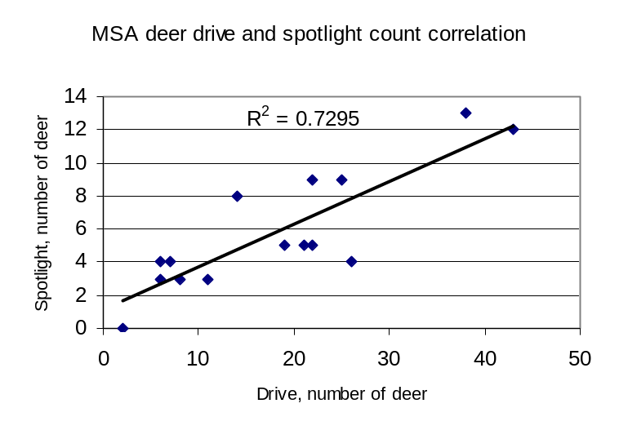
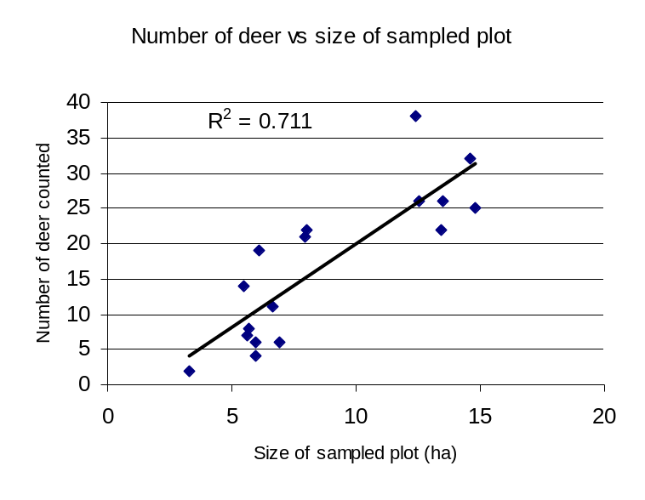 The number of deer counted on the drives correlated with the size of the plot (r² = 0.71) but there was no correlation between plot size and the number of pigs counted (r² = 0.20)..

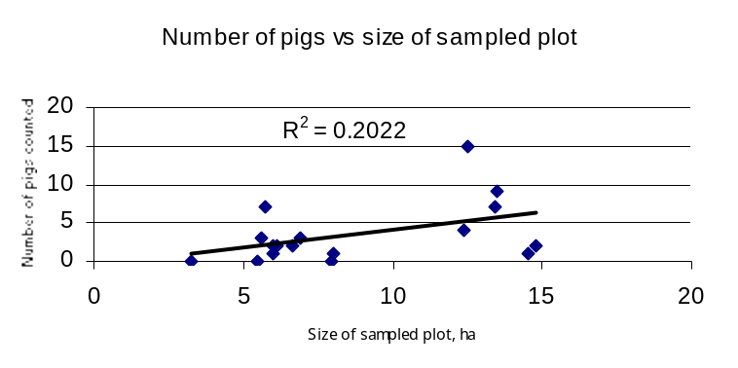
Spotlight and drive counts yielded inconsistent estimates of the composition of the deer population. The drive technique produced the following: adult males – 16%, adult females – 36%, fawns – 11%, and unknown – 37%. The spotlight counts produced the following: adult males – 6%, adult females 21%, fawns – 21% and unknown – 52%.

DISCUSSION
The average mass for deer on Guam is 52 kg (Wiles et al 1999) and the average mass for harvested pigs was 35 kg (Conry 1989). If these averages apply to the population sampled by our counts, we observed a biomass average of 95kg/ha (75-115) for deer and 13kg/ha (7-19) for pigs. The total ungulate biomass estimate is an extraordinary 108kg/ha (82-134).
Such high densities are likely to cause destruction of island vegetation, which have not co-evolved with browsing animals. White-tailed deer in their native habitat have been shown to cause decreases in abundance of songbirds, trees, herbs and shrubs at densities greater than 7.9 deer/km² (deCalesta 1997). The deer densities on MSA-1 are 23 times higher than this (183 deer/ km²). Our density estimate is also three times higher than Wiles et al. suggested in 1999. The pig numbers are similar to a previous estimate for AAFB of 0.35-0.86 pigs/ha based on harvest data (Conry 1989). Our pig estimate is two to five times higher than those documented in Hawaii at Haleakala National Park, where pig densities were estimated at 8-15 pigs/km² (Anderson and Stone 1994). Interestingly, the Guam densities are similar to the goat (2/ha) and pig (0.42/ha) densities recorded for 500 ha Sarigan Island, to the north of Guam. (C. Kessler, pers. Comm.).
A health study of the AAFB deer herd found deer condition to be generally good, documented breeding in females before one year of age, and concluded that habitat carrying capacity had not yet been reached (Shea 1998). Population regulatory mechanisms have not been reported for this introduced population; these might be of value for managers wishing to maintain populations below a point of unacceptable damage to natural vegetation.
The difference between drive and spotlight counts in deer population composition is problematic. Because there is no distinct rutting season for this species, males will drop their antlers at any time of the year. This causes males to be mistakenly counted as females, which may account for the skewed sex ratios. The high numbers of animals listed as unknown are generally adults that the observers were not able to classify. There should be fewer problems with observer bias for fawn classification, but this is difficult to verify. Almost twice as many fawns were observed during the spotlight count as during the drives. Because of these classification problems, demographic data collected by this study should probably not be used for management decisions.
By skipping three of every four adjacent units we probably avoided most or all problems with double counting driven animals. A few individuals may have remained in the plots undetected. Thus the high population density estimates obtained by drives are likely to be conservative. By comparison, the deer population estimate from DISTANCE underestimated the true number several fold. Apparently the density of deer on road edges at dusk in MSA is not representative of the overall habitat.
The lack of correlation between plot size and pig abundance suggests that pigs, unlike deer, are patchily distributed in MSA.

MANAGEMENT IMPLICATIONS
Deer and feral pigs have been present on Guam for several hundred years. Thus, any ecological damage associated with their initial irruptions occurred before the process was recorded. If so, what has happened to Guam’s habitat since the introduction of S. scrofa and C. mariannus and what has been lost centuries before we even started to address the problem? Previous studies have indicated that alien ungulates are having major effects on Guam’s plant diversity (Morton and Amidon 1998, Perry and Morton 1999, Wiles et al. 1999), however suitable control areas have not been used, so the extent of ungulate effects are unknown. Excessive ungulate browsing, combined with a lack of native pollinators, could be having severe effects on the remaining native plant species.
Extensive ungulate damage in hunted areas (bow and gun hunting areas) on AAFB (Perry et al. 1997, Morton and Amidon 1998) suggests that the management effects of hunting are quite small. Thus, either more extensive hunting is required, or additional tools should be brought to bear (Perry and Morton 1999). We feel that sport hunting is not efficient enough for serious population control and that more efficient harvest tools should be used.
For native plant conservation and endangered species habitat, the ungulate population must be reduced. However the popularity of recreational hunting makes this a politically difficult task and the logistics of an island wide reduction/eradication program even more so. It is difficult to maintain significant population reductions without eliminating immigration from the surrounding area. There have been successful deer control programs in the mainland U.S. that have lowered deer numbers while allowing immigration (Frost et al. 1997), but we know of no successful pig control program on an island that did not eliminate immigration.. Ultimately we feel that Guam will have to follow the Hawaii example by fencing off large habitat management units, and eradicating deer and pigs within the unit. Priority for such a program should be focused on planned endangered species reintroduction areas and surrounding endangered species habitat.

ACKNOWLEDGMENTS
We would like to acknowledge the numerous volunteers who aided this study from December 2000 to May 2001. Special thanks goes out to the Andersen Air Force Base Volunteer Conservation Officers (Class of 2001), staff from Guam’s Division of Aquatic and Wildlife Resources and staff from U.S. Geological Services-Biological Resources Division.

LITERATURE CITED

Aguon, C. F. 1990. Determination of current population size and distribution of Guam
deer. In R.D. Anderson, G.J. Wiles and L.L. Mariano (eds). Guam Division of Aquatic and Wildlife Resources Annual Report, pp. 109-116.
Anderson, S.J. and C.P. Stone. 1994. Indexing Sizes of Feral Pig Populations in a
Variety of Hawaiian Natural Areas. Transactions of the Western Section of the Wildlife Society 30:26-39.
Barrett, R.H., 1982. Wild Pigs. Pages 243-244 in D.E. Davis, ed. CRC handbook of
census methods for terrestrial vertebrates. CRC Press Inc., Boca Raton, Fla.
Buckland, S. T., D. R. Anderson, K. P. Burnham and J. L. Laake. 1993. Distance sampling: estimating abundance of biological populations. Chapman and Hall, London.
Conry, P.J. 1986. Determination of current population size and distribution size of
Guam deer. In R.D. Anderson and P.J. Conry (eds). Division of Aquatic and Wildlife Resources Annual Report, pp. 58-66.
_____. 1988. Management of Feral and Exotic Game Species on Guam. Transaction
of the Western Section of the Wildlife Society, 24:26-30.
_____. 1989. Ecology of the wild (feral) pig (Sus scrofa) on Guam. Division of Aquatic
and Wildlife Resources, Department of Agriculture, Government of Guam. Technical report No. 7.
Decalesta, D. S. 1997. Deer and ecosystem management. The Science of
Overabundance, Deer Ecology and Population Management. Editors, McShea W.J., Underwood H.B., and J.H. Rappole. Pp 185-198.
Frost H.C., G. L. Storm, M. J. Batcheller, and M. J. Lovallo. 1997. White-tailed deer
management at Gettysburg National military Park and Eisenhower National Historic Site. Wildl. Soc. Bull. 25:462-469.
Intoh, M., 1986. Pigs in Micronesia: introduction or re-introduction by the Europeans?
Man and Culture in Oceania 2:1-26.
Iverson, J.B., 1978. The impact of feral cats and dogs on populations of the West
Indian rock iguana Cyclura carinata. Biological Conservation 6:118-133.
Lewis, J. C., L. B. Flynn, R. L. Marchinton, S. M. Shea and E. M. Marchinton, 1990.
Ecology of sambar deer on St. Vincent national Wildlife Refuge. Tall Timbers
Research Station publication.
Morton, J.M. and F. A. Amidon. 1998. Baseline survey of vegetation in Area 50
Anderson Air Force Base, Guam. Report for Environmental Flight 36 CES/CEV, AAFB, Guam.
Perry, G., B.H. Coupe and N.L. Andersen. 1997. Vegetation survey results, Northwest
Field, November 1997. Unpublished report on file with the U.S. Department of Defense and U.S. Fish and Wildlife Service. 9pp.
_____, and J. Morton. 1999. Regeneration rates of the woody vegetation of Guam's
Northwest Field following major disturbance: land use patterns, feral ungulates, and cascading effects of the brown tree snake. Micronesica 31 (2):125-142.
Quinata, L.R., 1994. Vegetation Baseline Survey Andersen Air Force Base, Guam.
U.S. Fish and Wildlife Service.
Savidge, J. A., 1987. Extinction of an island avifauna by an introduced snake. Ecology
68 (3): 660-668.
Schaller, G. B., 1967. The deer and the tiger, a study of wildlife in India. The
University of Chicago . Chicago and London.
Schaller, G. B., 1972. The Serengeti lion. The University of Chicago Press. Chicago
and London.
Shea, S. M. 1998. Evaluation of herd management and physical condition of Sambar
Deer on Anderson AFB, Guam. Sambar deer report, Anderson Airforce Base,
Guam, USA.
Singer, F. J., and J. A. Mack. 1999. Predicting the effects of wildfire and carnivore
predation on ungulates. Carnivores in ecosystems, the Yellowstone experience.
Yale University, USA. Pp 189-237.
Taborsky, M., 1988. Kiwis and dog predation: observations in Waitangi State Forest.
Notornis 35:197-202.
USDA, 1988. Soil Survey of Territory of Guam. U.S. Department of Agriculture, Soil
Conservation Service.
Wheeler, M.E., 1979. – The biology of the Guam deer. Guam Division of Aquatic and
Wildlife Resources Technical Report No. 3.
Wiles, G.J., Buden D.W., and Worthington, D.J., 1999. - History of introduction,
population status, and management of Philippine deer (Cervus mariannus) on Micronesian Islands. Mammalia 63 (2):193-215.

Received -

Accepted -

Associate Editor -

Present address: 1310 Bear Creek Rd., Colville, WA 99114
Commander, PACNAVFACENGCOM, 258 Makalapa Dr Ste 100, Pearl Harbor, HI 96860-3134 3 E-mail: VogtSR@efdpac.nafac.navy.mil
mil

